S.VIMALRAJ

NM ID : B4166FBF4DCA8C3B14A436001C2BCA1F

BLOCK CHAIN

ASSIGNMENT

SRI RAAJA RAAJAN COLLEGE OF ENGINEERING AND TECHNOLOGY

1. Go to the chrome and open remix platform

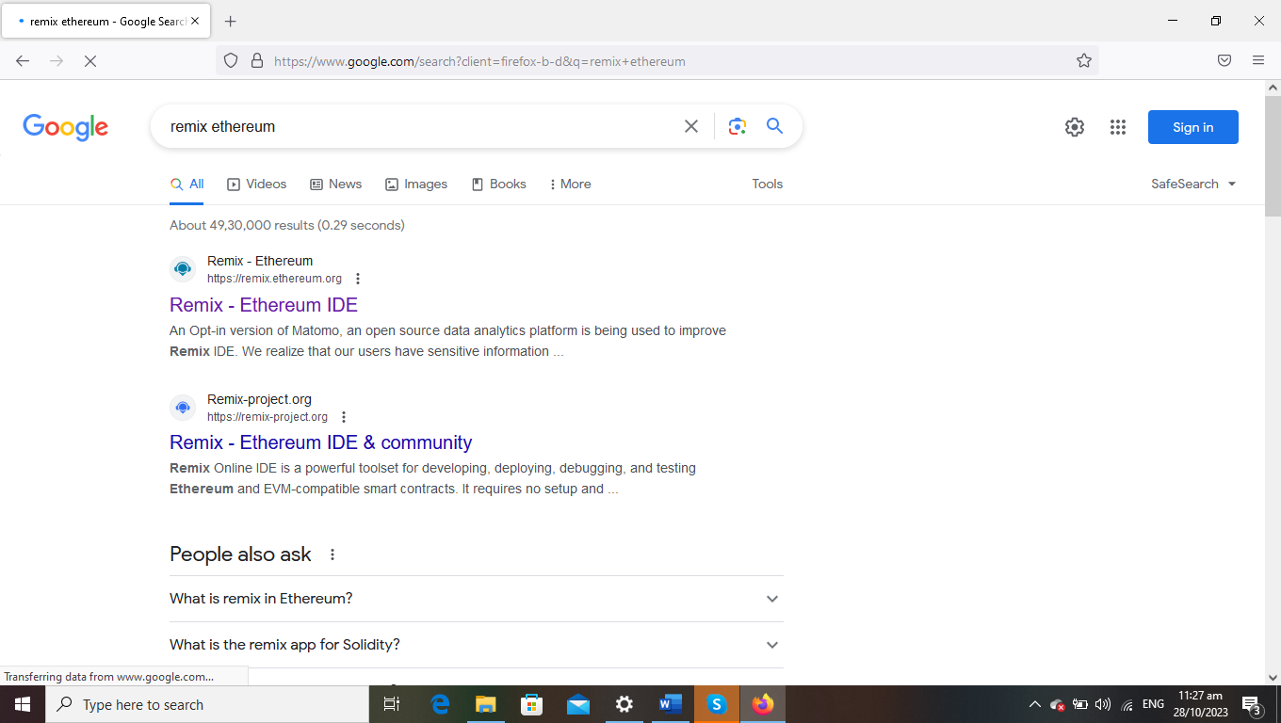

2.Open the remix page and create a new FILE

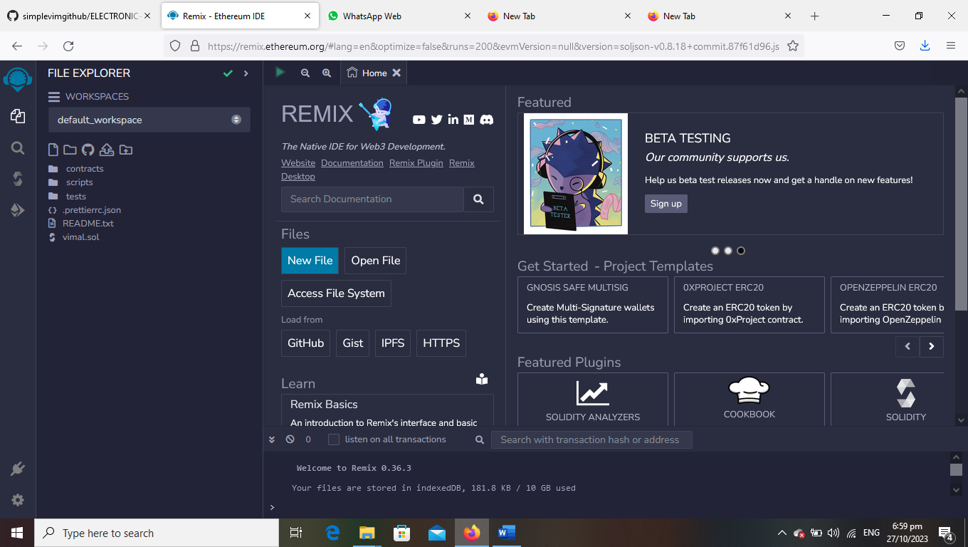

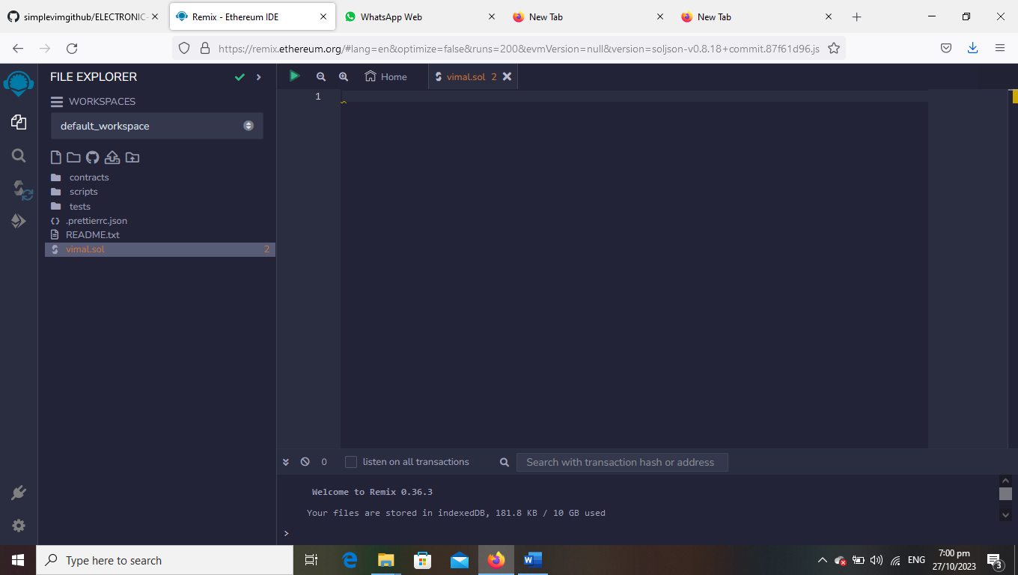

3.create a program to return your string ”ZONE NAME”

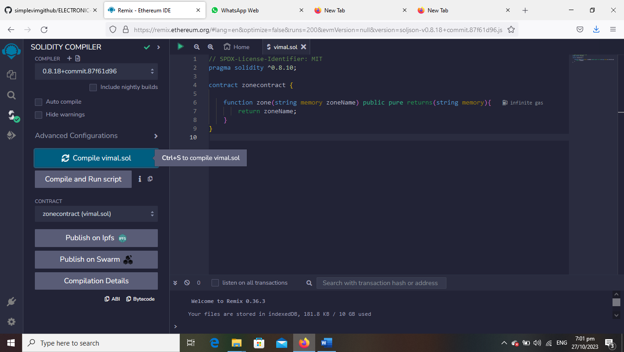

4.compile it det ABI code and BYTECODE

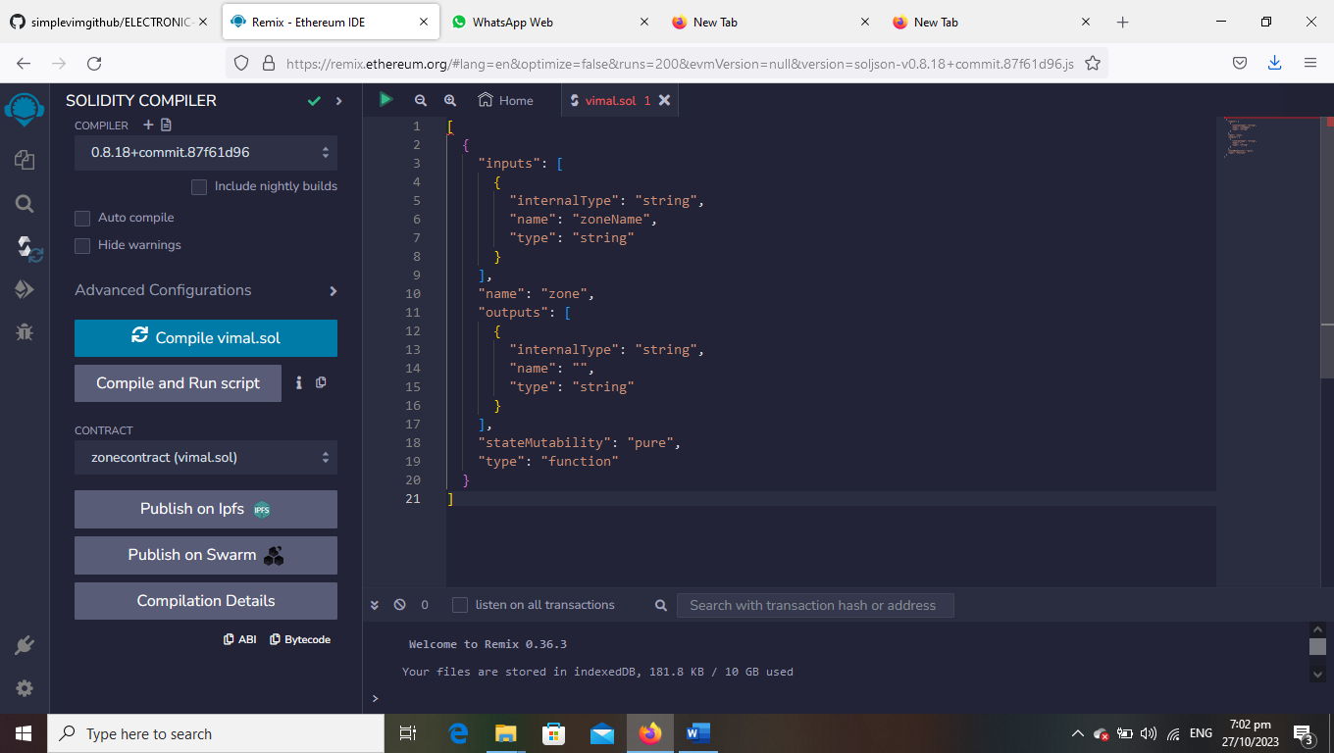

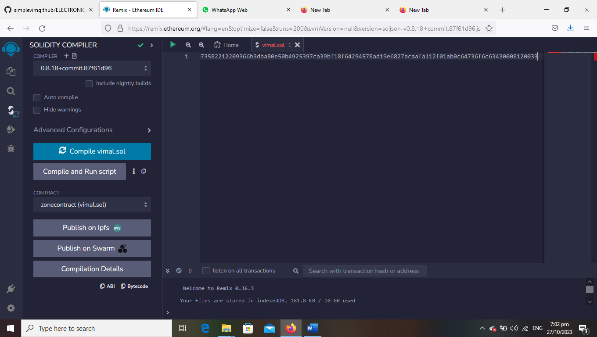

5.Deploy it to display the out put

